DO IT – Front End developer

Mini project 1 – XYZ Travel Agency – HTML BASICS

SMART d.o.o, New Frontier Group

Version: 1.0

Revision date: July 26, 2016

Table of Contents

Specification of mini project 2

Requirements for this project 3

Tasks 4

Timeline 5

Tools 6

# Specification of mini project

In this mini project your task will be create same page as shows in miniproject1.jpg.

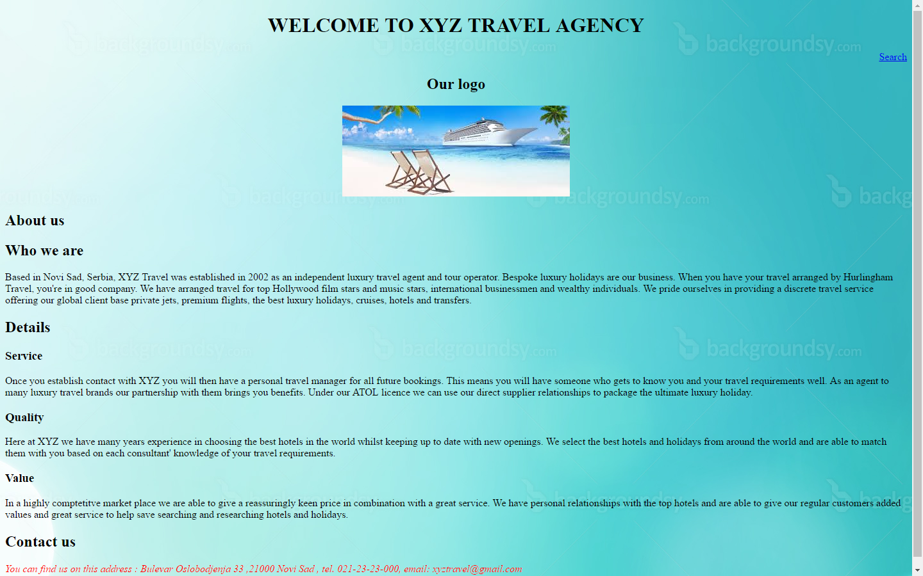

Picture 1 – miniproject1.jpg

Scope of this project is to use html basic elements to make your first web page.

You will use text file xyz.txt for every text that you need for this project and that is entered as you can see in miniproject1.jpg preview.

# Requirements for this project

Before you can start with this project you need to finished HTML fundamentals class.

**Tasks**

So your job is to do next :

1. Create new index.html document
2. Write DOCTYPE declaration with English language.
3. Create basic structure of html document and include html,head,body tags.
4. Define meta tag with UTF-8 charset in head tag.
5. Define title element with text “MINI PROJECT 1” in head tag.
6. Use image background-10.jpg as you background image.
7. Name this site as Welcome to XYZ travel Agency and put this name in h1.
8. Add text Our Logo in h2 tag.
9. Insert logo image pic3.jpg from images folder and put Travel agency text as alternative text.
10. Make name of this site and name of logo (Welcome to XYZ travel agency , Our logo) with logo picture in center of page.
11. Now make new h2 tag in one put text About us ,and in another put text Who we are.
12. After that put text from xyz.txt file that is below How we are in paragraph.
13. Next insert in h2 name Details after which put div class with name row.
14. Now you make three more div inside this div. Each div will have name Service,Quality, Value respectively with paragraph each. Text of each paragraph can be found in xyz.txt
15. After all div tags put new text named Contact us in h2 tag.
16. Put text below h2 from xyz.txt file in paragraph and then make color of text in red, and make text italic.
17. Save your work and test it in web browser.

Your result should look like on picture miniproject1.jpg

**Additional tasks**

1. Try to change name of logo picture to pic.jpg ,save document and run in web browser. See what happens !
2. Between name of site and name of logo put link to [www.google.com](http://www.google.com) , name this link as Search and align it to righ side of page.

Good luck!

# Timeline

You will have 3 hours to finish this job.

This timeline is for main parts of the task. Bonus parts should be implemented only if there is extra time left.

# Tools

## IDE and Source Control

You can use either Atom or Brackets tool for development during this project

ATOM - <https://atom.io/>

BRACKETS - <http://brackets.io/>